## **FhirStore to S3 Export**

### **Purpose**

This document provides step-by-step instructions for programmatically exporting data from an already de-identified fhirStore to an S3 bucket.

### **Requirements**

AWS: S3 permissions

GCP: Google Cloud Storage permissions

Credentials to programmatically use the GCP

### **Procedure**

#### **Step 1: Install the Necessary Libraries**

pip install google-auth google-auth-oauthlib

pip install boto3

#### **Step 2: Import Libraries**

#### **Step 3: Load Credentials i.e. From File or From Environment Variables for GCP and AWS**

#### **Step 4: Create a Session to Request Data from FhirStore and Setup FhirStore Location Information**

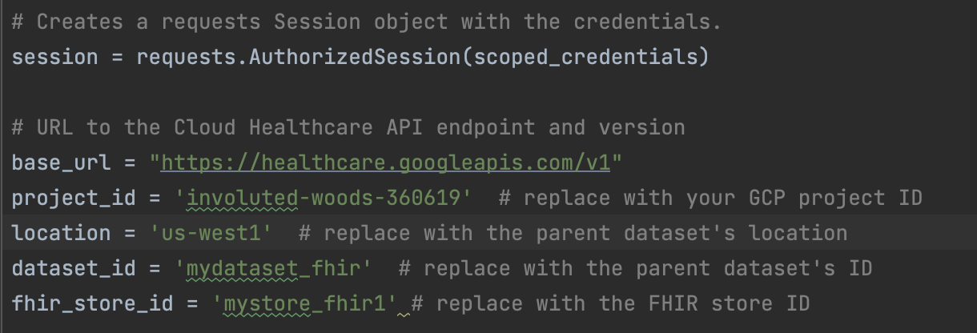

#### **Step 5: Create a Boto3 Session to Use AWS S3 and Specify the Bucket Name**

#### This assumes that a folder was already created in S3 and has access to the public.

#### 

**Step 6:** **Create a File Called Resources that will Have a List of All the Resources In a FhirStore**

1. Each entry in the file should have a name on its own line being delimited by an “enter” after each resource name

**Step 7: Load all the Entries from the Fhir Resources File**

1. Loop through all the entries and add it to a list

**Step 8: Create a Loop That Will Go Through Each Resource In Resources file**

1. It gets all the entries on the first page (50 entries at max) of the resource in the fhirStore through a query
2. Introduces a counter for unique file names in AWS

**Step 9: Keep looping through all the Pages and Entries in the Resource**

1. Query the resource path from the previous step
   1. Check if there is at least one entry in it
2. Process those entries on the first page and post it to the AWS S3 bucket with a unique name in the format Resource_Type(count)
   1. Encode and format the data to use
   2. Post the data to the AWS S3 Bucket
      1. The Key is the sub_folder_name/new_file.json
      2. Bucket is the main folder defined earlier
      3. Body is all the json entries in string format for a page of a resource
   3. Go to the next page of the resource if there are entries and post those ones to the S3 bucket as well

**Step 10: Go to the AWS S3 bucket and the Sub Folder and Check if the Data was Correctly Imported there**

## **Conclusion**

Configured a script that queries all the resources in a fhirStore on GCP that has already been de-identified and posts that data to an S3 bucket on AWS. The script is a stand-alone Python Script and uses hard coded source and endpoints.